Monstah Operating System

Dan Mangiarelli
Craig Fargione
Dave Weisfelner

System Documentation v1.0.3

Introduction

Welcome to the Monstah Operating System guide. Here we will take a deep look at the mechanics, principles and ideas of that help make up the Monstah Operating System or MOS for short. MOS is comprised of a two basic pieces. First we have the simulated CPU and its associated components. The other half is an input file, which itself is comprised of control, program and data cards.

CPU Structure

The CPU in the MOS is simulated. By that we mean, it does not physically exist, but our program simulates the behaviors of a collective of pieces that emulate a real machine, albeit a very basic one. In the picture below we show the basic components that we are attempting to duplicate via means of software.

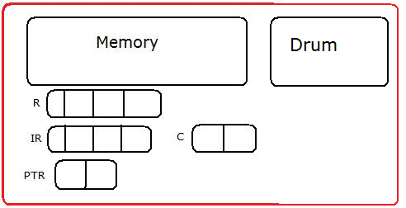

Memory – a 300 x 4 array of 4 byte words that is shared by both program and data cards.

Drum – A 100 x 10 x 4 array that is used for storing program instruction cards.

R – Is short for General Purpose Register, is controlled by the user through several commands listed later.

IR – Instruction Register is used by the MOS load the next instruction specified by the address in IC and is then executed by MOS.

IC – Instruction counter will tell the MOS the address of the next instruction.

C – A small one byte register used to store a 0/1 toggle later used in branching.

PTR – This contains the page table base location for the user process currently running.

SI – (not shown on diagram) Interrupt register used to handle I/O.

PI – (not shown on diagram) Interrupt register used to tell if there is a page fault.

TI - (not shown on diagram) Interrupt register used to tell if the time slice or total time is up.

IOI – (not shown on diagram) Flags that indicate which Channel to start.

(Each of the three interrupts will be explained in further detail in the Program Commands section of this documentation.)

Input File

The input file, and correct formatting of it, is essential to the MOS executing programs properly. Each program needs to be listed in immediate succession of the previous program, no breaks are allowed. Each program must consist of three control card statements, at least one program card and usually, but not necessarily one or more data cards.

Control Commands

$JOB –

This control command must be specified in each program. It tells the MOS that it is at a new program. To go along with this command, $JOB must be followed by a sequence of numbers that MOS will also use to determine certain aspects about the program. A string of 12 numbers must exist, each broken down into 4 numeric numbers.

The first set of 4 relates to the program’s name, i.e. 0401 would be program number 1 (01) from group 4 (04). Program numbers do not need to be in any kind of order, but they do need to be unique.

The middle 4 numbers are a time counter. To prevent a user error and having MOS run endless loops, there exists a counter that a user specifies to indicate the maximum number of instructions that MOS should attempt to execute before it must exit. If a value of 0083 is given, a maximum of 83 instructions will be run before MOS will terminate.

The last group of 4 is a print limit counter. Like the time limit, it exists solely to prevent users from creating endless printing loops. If the last set of 4 numbers were to read 0003 only 3 lines could be printed before MOS will terminate.

All together the opening line can be very cryptic but it is important never the less that a user properly fills it out. As a final example consider the entire line

$JOB040101820032

Here we can see that we have a new program, named 0401 because it is the first program from group number 4. It can execute for a maximum of 182 time units and print a total of 32 lines to terminate properly.

Program Cards

Once the header line has been read and the system variables for execution and print limits has been set, MOS will read the next ensuing lines as program cards until it reaches the next control card delimiter. Program cards are read 10 4-byte words at a time. They are placed at memory location 0 through 9. If there are more than 1 program cards, each card will be read into the MOS memory at similarly increasing memory locations. So program card 2 will be read into memory location 10 through 19, card 3 will be read into locations 20 through 29 and so on. This incrementing is handled automatically by the MOS and the user cannot control where program cards are placed.

$DTA

MOS cannot tell what is a program card, or a data card, or anything for that matter. It relies upon the control commands to tell it what’s next. Accordingly, once MOS has started reading program cards, it will continue to do so until it comes across this command. At this point the MOS will read this line in and it will signify that all program cards have been entered, and execution of the program should commence. It is also a marker to let MOS know that any future lines are either data cards, used and accessed by the program, or the $EOJ command to end the program.

Data Cards

While not required, most programs will follow the $DTA command with data cards. These are used by the user to bring input into the MOS. They are read 40 bytes at a time into a location specified by the GD command which is explained further in this manual. Data cards are vital to creating useful programs for the user but the MOS does not need to handle them until called for and if no GD is ever used

$EOJ

This command will be followed by a sequence of 4 numeric numbers which should match the program number specified by the $JOB tag. Upon reaching this line MOS will know to it has reached the end of the program and will either load the next program or terminate the simulation.

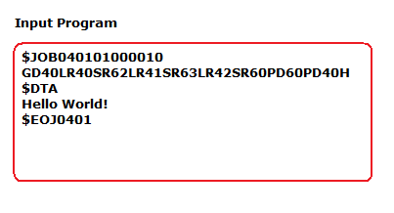

Shown above is a sample program. From what has been described so far we can see that this program had a number 1, it should run no more than 100 time units, and print no more than 10 lines. It has one program card that starts with GD40 and it also has one data card “Hello World!” The ending tag matches up with the opening one and this will end up running our basic hello world program successfully.

Program Commands

Thus far all that has been discussed are the internals of the CPU and some basic formatting of the input file. To make a program and be useful, the user must understand how program commands work, and the MOS must interpret them correctly. When MOS begins executing any given program it will expect to encounter one of 7 commands or throw an error.

The commands are handled in different areas of the MOS. Because Input, output and exiting a program are must more taxing operations then the simpler load, store and compare commands MOS handles the commands in different ways. A “slave” mode is used to handle most of the commands while interrupts are set for others.

Master Mode:

The MOS is responsible for many other functions then just handing a few commands in a program. The system must handle input and output, and interrupts that may have been raised. Additionally many housekeeping activities are done in the master mode such as clearing out registers and memory between programs, handling the different program ID numbers, incrementing instruction and print counters and also handling their logical checks to determine in a program needs to terminate or not.

During execution the SI interrupt can be raised at any time and the Master Mode will ne called to help handle the instruction. Based on the Value of SI, MOS will handle the procedure accordingly.

Supervisor Interrupt (SI)–

Service interrupt is a register used internally by MOS for special cases where the slave mode cannot handle a certain operation in an attempt to simplify what the slave mode should be doing.

SI = 1
This interrupt is raised when the program instruction GD is encountered. At this point in the program, the MOS goes into Master Mode and Master Mode takes care of the input. It takes the next line of data and stores it into the memory location starting at the address in the Instruction Register. It will continue to store the data until it either fills up that memory location or until there is no more data to store in that memory location.

Example:

With the instruction GD50, when control is transferred to Master Mode, data from the input file is taken into an empty buffer, making it an Input Full Buffer (IFB), and the data is then stored into the drum. From the drum, the data is brought into memory when it is time for the program to be executed.

SI = 2
This interrupt is raised when MOS encounters the PD program instruction. The MOS then transfers control to Master Mode and Master Mode takes care of printing the data in memory. Master Mode takes the data starting in the location given in the Instruction Register through the other 9 memory locations.

Example:

With the instruction PD50, Master Mode will go into memory and send locations 50 – 59 to an empty buffer, which then becomes an Output Full Buffer (OFB). The OFB will then place the output into the drum and from the drum it will be printed when it is time to print the data.

SI = 3
This interrupt is raised by the Halt command in the program instructions part of the input file. When the MOS is executing the program instructions and it reaches this instruction, this interrupt is raised and the MOS realizes that this is the end of the program and it halts execution. At this point, execution of the next program in memory is started and if there is no new program in memory, the next program is loaded into memory and then execution is started.

Example:

When the program gets to the H command that has been stored in memory already, the program has successfully gotten to the end of the program, and at this point any output that was stored in the drum for this program is outputted. Once that is complete, the execution of the next program is started.

Time Interrupt (TI)-

This interrupt is used for the timing of the user programs. The interrupt has three different values and each has a different meaning for the program.

TI = 0
There have been no time errors in the program. This means that the program has run successfully and there were no errors in the program.

TI = 1
When TI is equal to 1, the Time Slice Interrupt has been raised. The Time Slice Interrupt is used for when you have multiple programs in memory and each is given a certain amount of time to run before it is moved to the end of the Ready Queue and a new process is given priority of the CPU’s resources. The amount of time that is allocated for each program to run before a new program is given access to the CPU is 10 time units. When the allotted time is up, the current program is taken away from the CPU so that the next program can be run for the same amount of time and each program gets the same amount of CPU time.

TI = 2
When TI is equal to 2, the Time Limit on the program has been exceeded and the program execution is to be terminated. As soon as the time limit has been reached, this interrupt is raised and MOS terminates the currently running program and throws an error message that is printed so the user knows why the program terminated before it was run completely.

Page Interrupt (PI)-

This interrupt is raised if there was an error in the data card or in memory.

PI = 1
When PI is equal to 1, this is signifying that there was an operation error. This would happen if a user meant to write GD for Get Data and instead wrote FD by accident. FD is not a recognized command by MOS so it will raise this interrupt and an error message will be printed to allow the user to see why the program execution has been terminated.

Example: Someone writing FD40 instead of GD40 because they hit a wrong key by accident and there is no operand that begins with the letter F.

PI = 2
When PI is equal to 2, this is signifying that there was an operand error. This would happen if someone placed a letter or some other character in the operand field of the instruction. If this is discovered in a user program, the PI interrupt it raised and set to 2 and an error message is printed to allow the user to see why their program was terminated.

Example: Someone writing GD5o instead of GD50.

PI = 3
When PI is set to 3, this signifies that there has been a page fault. There are two types of page faults, valid and invalid. A valid page fault is when you are trying to store data and there is memory available to be allocated for the data. The memory location is then allocated and program execution continues. An invalid page fault occurs when the OS is trying to read data from memory that has not been allocated. This causes and error and the program execution is terminated.

IOI –

These are flags that, given a certain value, tell the MOS which channel to start. Each channel has its own function. For example, if the value of IOI is 1, Channel 1 is started. If IOI equals 2, Channel 2 is started. Further examples of the value to Channel conversion are as follows:

Cases of IOI:

0 No Action
1 IR 1 (start Channel 1)
2 IR 2 (start Channel 2)
3 IR 1, IR 2 (start Channels 1 and 2)
4 IR 3 (start Channel 3)
5 IR 1, IR 3 (start Channels 1 and 3)
6 IR 3, IR 2 (start Channels 2 and 3)
7 IR 1, IR 2, IR 3 (start Channels 1, 2 and 3)

Channels –

Channel 1 (IR 1):

Channel 1 takes care of the input from the file into the drum. It starts with an Input Full Buffer (IFB) which has the program cards from the user program on it. It starts out by initializing a page table and a page table register once it has found the $AMJ marker. It then knows that program cards will follow and sets a flag accordingly. Once the program cards have been read into the drum and that buffer is empty, its status is changed from IFB to empty buffer (EB). The EB is then returned to the empty buffer queue.

When the $DTA marker is found, the program knows that data cards will follow, and a flag is set accordingly. Once the data has been read into the drum, the status of the buffer is changed from IFB to EB and the buffer is returned to the empty buffer queue.

When the $END marker is found, the PCB is placed on the load queue, the buffer is changed from an IFB to an EB and it is returned to the empty buffer queue.

Channel 1 takes 5 time units to transfer data.

Channel 2 (IR 2):

Channel 2 deals with the program output. An output full buffer (OFB) is sent to Channel 2 and the data that is in the buffer is then printed to the file. The status of the buffer is then changed from OFB to EB and the buffer is returned to the empty buffer queue. If the output full buffer queue is not empty, then the next OFB is processed by Channel 2. This continues until the output full buffer queue is empty.

Channel 2 takes 5 time units to transfer data.

Channel 3 (IR 3):

Channel 3 is the most complicated of the three channels. This is because out of all the channels, it does the most. For different tasks, there is a different set of operations that Channel 3 does.

Input Spooling

First it takes the data in the IFB and writes it to the specified drum in the track. Next the track number is placed into the P or D part of the PCB so that it can be found again. It then changes the status of the buffer from IFB to EB and then returns the buffer to the empty buffer queue.

Output Spooling

First it reads the information from the drum track into an empty buffer. The status of the buffer is then changed from EB to OFB and the buffer is returned to the output full buffer queue and the drum track is then released. Next the line counter in the PCB is decremented. If it’s the last line, then two other buffers are filled with blanks, their status is changed from EB to OFB and they are returned to the output full buffer queue. Once this is done, the drum tracks, PCB and all memory blocks are released. Termination lines are then prepared and placed onto the Terminate Queue (TQ) then placed into an OFB and placed on the output full buffer queue.

Load

First the program card is loaded from the specified track into memory. Then the count in the PCB is decremented and if it is 0, the PCB is placed onto the Ready Queue (RQ) after all of the initializations.

Read
First the data card is read from the given track into memory and the counter is decremented in the PCB. The PCB is then moved to the RQ after the TSC is set to 0.

Write

Write information from the indicated memory block to the given track, then the line count in increased in the PCB. If TI=2 or 2 the PCB is moved to the TQ. Otherwise the PCB is moved to the RQ after setting TSC = 0.

Memory Queue

Check if waiting on PCB.

Once these tasks are complete, they must be assigned in priority order.

If a PCB on TQ (output spool first)
If EBQ not empty
Get next buffer from EBQ
Find track number of next output line
Task <- OS
Start CH 3

Else (input spool next)
If IFBQ not empty and a drum track available
Get next buffer from IFBQ
Get a drum track
Task <- IS
Start CH 3

Else (load next)
If a PCB on LQ and a memory frame available
Find track number of next program card
Allocate a frame
Update page table
Task <- LD
Start CH 3

Else (now I/O)
If PCB on IOQ
If Read (GD)
If no more data cards
Move PCB, IOQ -> TQ [Terminate (3)]
Else
Find track number of next data card
Get memory RA
Task <- GD
Start CH 3

Else If Write (PD)
If TLC > TLL, Move PCB, IOQ -> TQ [Terminate (2)]
Else
Get a drum track
Update PCB
Find memory RA
Task <- PD
Start CH 3

Else (allocate memory)
If PCB on MQ
If memory frame available
Allocate
Update page table
Adjust IC
Move PCB, MQ -> RQ with TSC <- 0

Else
Run page replacement algorithm
Find victim frame
Allocate and deallocate frame by updating page table
If victim frame not written to, locate drum track
Task <- MQ
Start CH 3
Else
Task <- MQ
Start CH 3

Channel 3 runs for 2 time units.

When two interrupt messages are combined, they can create multiple error messages. These error messages are defined below. For the definition of the error messages, see the Program Output section of this documentation.

Cases of TI and SI:

TI SI Action
0 or 1 1 -------- Move PCB, RQ -> IOQ (Read)
0 or 1 2 -------- Move PCB, RQ -> IOQ (Write)
0 or 1 3 -------- Move PCB, RQ -> TQ (Terminate [EM 0])
2 1 -------- Move PBC, RQ -> TQ (Terminate [EM 3])
2 2 -------- Move PCB, RQ -> IOQ (Write then Terminate [EM 3])
2 3 -------- Move PCB, RQ -> TQ (Terminate [EM 0])

Cases of TI and PI:

TI PI Action
0 or 1 1 -------- Move PCB, RQ -> TQ (Terminate [EM 4])
0 or 1 2 -------- Move PCB, RQ -> TQ (Terminate [EM 5])
0 or 1 3 -------- Page Fault
If Valid
If Frame Available
Allocate
Update Page Table
Adjust IC, If Necessary
Else
Move PCB, RQ -> MQ
Else
Move PCB, RQ -> TQ (Terminate [EM 6])

Cases of TI and PI (con’t):

2 1 -------- Move PCB, RQ -> TQ (Terminate [EM 3, 4])
2 2 -------- Move PCB, RQ -> TQ (Terminate [EM 3, 5])
2 3 -------- Move PCB, RQ -> TQ (Terminate [EM 3])

Slave Mode:

Slave mode is the simulation of program instructions that have to deal with memory access and execution. Input and output procedures are left for the master mode to handle. Only instructions relating to registers are handled here.

Get Data – GDXX

Description: Get data command is a way for the user to read in data cards that they have placed. MOS reads the first two characters to determine that this is a get data command and then use the address associated with the instruction to determine where to place the next line of data in memory. The last number will be dropped and a 0 placed in its place, and all 40 bytes of the next data card are read into 40 bytes in memory, in that respect GD53, GD59 and GD50 are all exactly the same as they will all load the next data card in memory locations 50 through 59.

Consider a program that has GD54 as the next instruction and the data card “Hello World!” as the next data card. MOS will drop the 4 and essentially make the command GD50. It will then load “Hell” into location 50, “0 Wo” into 51 and “rld!” into location 52.

Slave Mode Operation: SI = 1

Print Data – PDXX

Description: Similar to get data, print data will drop the last numeric value in the address, set to 0, and then access all 40 bytes at a time. Instead of gathering information though, PD will print that 40 byte stream onto the screen and an output file.

Slave Mode Operation: SI = 2

Halt – H

Description: Halt command tells MOS that the program is done executing and it can terminate.

Slave Mode operation: SI = 3

Load Register – LRXX

Description: Load Register will take the content at the specified memory location and place it in the general purpose register

Slave Mode Operation: R <- M[IR[3,4]]

Store Register – SRXX

Description: Store register takes the content of the GPR and places those bytes are the given word address. It is the logical inverse of LR.

Slave Mode Operation: R -> M[IR[3,4]]

Compare Register – CRXX

Description: Compare register will look at the content of the GPR and compare that against the value of the memory location specified. If the two are equal, the compare register will be set to true.
Slave Mode Operation: Compare R and M[IR[3,4]], if equal C = T else C = F

Branch-To – BTXX

Description: If the compare register is set to true, the IC should be set to the address specified and execution will then take place from that point, else the command is skipped.

Slave Mode Operation: If C = T, then IC <-IR[3,4] else skip

Memory –

As shown below, memory is a simple array of 300 total words, where each word is separated into 4 bytes. Memory is show here as a 300 x 4 array. Each section represents 10 lines. So location 00 goes to location 09 before location 10 starts.

For example consider GD60, this command will take the next line from the data field of the program, and place all 10 words from there into memory locations 60 through 69. PD60 would accordingly print the data in memory locations 60 through 69. When program cards are read in when the MOS is initially loading a program, it will read an entire line at a time and place each line, or card, in memory. The cards will be placed 10 words at a time sequentially into memory.

This is not always the behavior however. LR64 for example, will access just the 4 bytes at location 64 and place them in the general purpose Register(R).
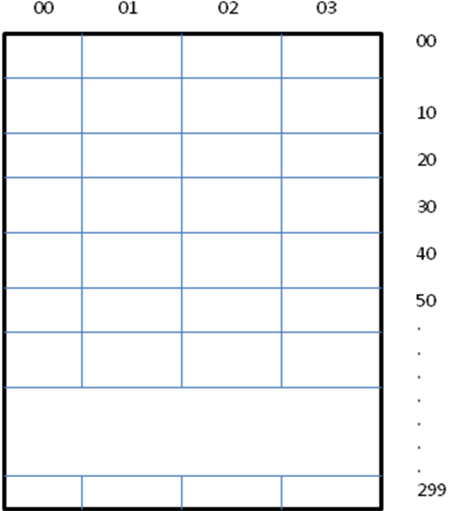

Paging –

In the MOS memory system, paging is used to allow non-contiguous memory usage. This allows memory to be allocated where there is a space large enough to fit it in memory. The paging scheme works by dividing the physical memory into fixed size blocks, called frames. Then it divides the virtual memory into blocks of the same size, called pages. As programs are executed, the available frames are kept track of and when a program comes in that requires n pages, the OS goes through and finds n free frames in physical memory. These frames do not need to be contiguous. Once the frames are allocated in memory, a page table is set up that maps the virtual addresses into the physical addresses. This allows for easy access to the physical memory.

The page table is kept in main memory. The Page Table Register (PTR) keeps track of the starting address of the page table.
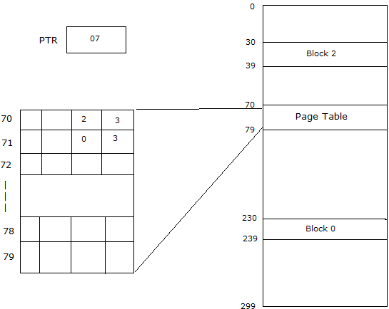

Retrieving data from memory takes two memory accesses. The two accesses are 1) to get the frame number out of the page table and 2) to access the correct frame given from the page table.

Drum –

The drum is a secondary storage device for the CPU. It is made up of a 100 x 10 x 4 array. Each of the 100 tracks in the drum has 10 words of storage, which are 4 bytes long. When it is time for the input file to be read into memory, the program cards are brought into a buffer, and then stored into the drum. The drum acts as an intermediary between the buffers, which get the data and program cards from the input program, and the main memory of the MOS. When it is time for the program to be executed, MOS will go into the drum and bring the relevant information from that program into main memory so that it can be executed.

Not only program instruction cards can be brought into the drum, all parts of the program can be stored into the drum. The drum can store program instructions as stated before, it can store data cards from a program that is being executed, and it can also store output from a program that is waiting to be outputted to the file.

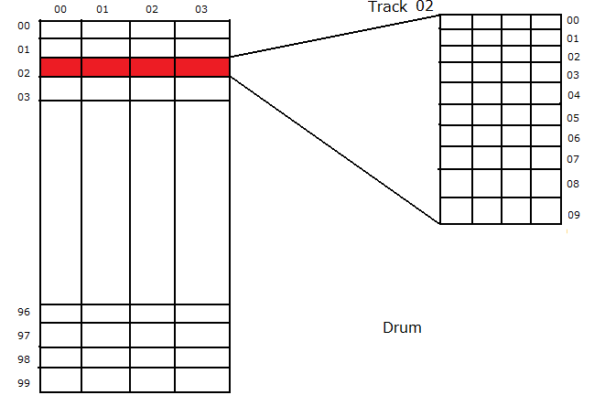

General Purpose Register –

The general purpose register, GPR, or R for short is a register that is available to the user for a few uses such as filling with information and or placing information in memory elsewhere. GPR is 4 bytes long to match any given word in memory. If a command comes in, LR64 for example, the content in memory at 64 will be placed in corresponding bytes in the GPR.

Instruction Register –

Access to this register is only available to the MOS. During the standard fetch, increment, execute cycle this register will be loaded with whatever exists at memory location in the instruction counter. This will need to be one of the seven valid commands available to the user or an error will result.

Compare Register –

A very small register designed to hold a 1 or 0 that is set by using the CR command. This register can only be set by the MOS and not by the user. It is set by CR and read by BT commands.

Instruction Counter –

At the heart of the MOS is the instruction counter. This 2 byte register is available to the user in a non direct way but mostly controlled through the MOS. When the execution of commands begins, the first instruction will be read from the address that resides in the IC. When the instruction has been executed the IC is incremented so that the next sequential instruction will be loaded into the IR and the cycle repeats. If a branch statement from the user program is ever read, and the condition associated with it reads true, the address next to the BT command will be overwritten in whatever the current IC has so that execution now “jumps” to where the user wishes the control of execution to go.

Program Output

The following are all part of the output and can be useful for debugging the program if it does not finish running correctly as well as tell the user what the value of all the registers are if it does complete execution correctly.

Value of:

IC – Instruction Counter
IR – Instruction Register
R – General Purpose Register
C – Compare Register
TTL – Total Time Limit
TTC – Total Time Counter
TLL – Total Line Limit
LLC – Line Limit Counter

These output lines will be printed with a message saying if the program terminated normally or abnormally depending on how the program completes. The first line will give the program ID number, normal or abnormal termination, the time limit and finally the line limit. The second line will print the value of the IC, IR, R and C followed by the number of lines printed and the total time taken to execute the program. An example of this is as follows:

ID0401 Normal Termination 0100 0010
IC = xx IR = xxxx R = xxxx C = x 0100 0010

When a program is terminated abnormally, the error message will be printed along with the two initial lines of output. The following are the error messages and their descriptions.

Error Messages:

The following error messages will be printed in the output file depending on if an error has occurred or not. These error messages will also be accompanied by a line that says normal or abnormal termination.

0 = No Error
- No error has occurred

1 = Out of Data
- The user is doing GD command and trying to get data, however there is not enough data to be brought into memory.

2 = Line Limit Exceeded
- The program has tried to print more lines than were allocated by the user.

3 = Time Limit Exceeded
- The program has exceeded the time allocated by the user for the program to run.

4 = Operation Code Error
- There was an error with the operation code(s) in the program. Most likely a misplaced character in the operation code field.

5 = Operand Error
- There was an error with the operand(s) in the program. Most likely a misplaced character in the operand field.

6 = Invalid Page Fault
- There was an error in the allocation of a page for a GD command in the program. Page accessed was not allocated in memory or trying to allocate a new page when memory is full.

Trace –

The trace is a cycle by cycle behavior of MOS.

For Master Mode, it will print out:
Process ID

Interrupt being handled:

PI = (1, 2, 3)

1&2 - Process Terminated
- Messages

3 - Valid/Invalid Page Fault
Invalid – Process Terminated and Messages
Valid – Frame number allocated
Process Started

TI = (1, 2)

1 - Process moved to end of Ready Queue
- Process ______ started

2 - Process ______ terminated
- Message lines

SI = (1, 2, 3)

1 - Line read in ___________________________________ Read in frame # ______
Line # ______

2 - _____________________________________________ Written from Frame #

3 - Process Terminated
- Message lines

1 - Error - Out of Data
- Process Terminated
- Message lines

2 - Error – Line # Exceeded ______

For Slave Mode, MOS will print out:

The Process ID
Value of IC
Real Address - (error? – Page Fault and the value of PI)
Value of IR Page Fault? -- Value of PI
Real Address

Operation Code
Action Taken (Read, Write, etc)
Operation Error – Value of PI

